ID.Nr. Pressemitteilung Service-Welt, FP, 27.4.2015 Geändert:
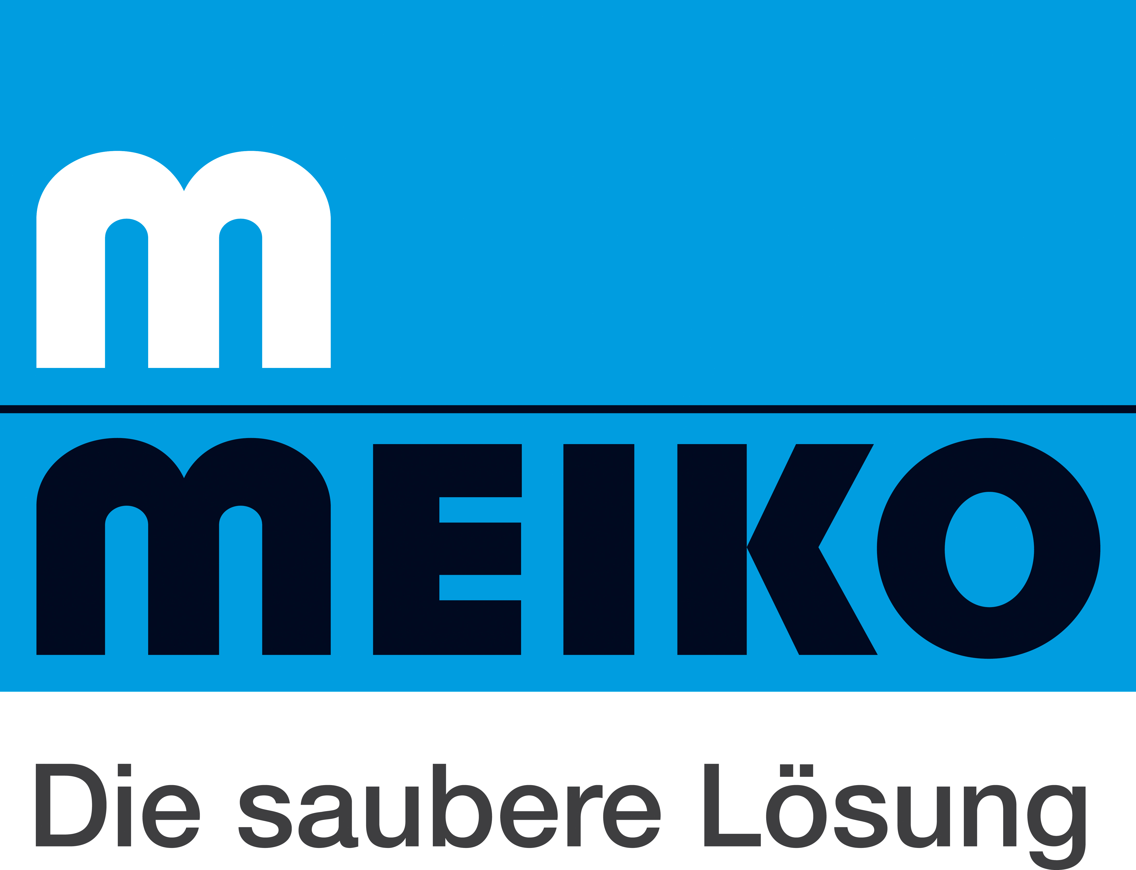

Four Million Euro Investment in New Meiko ‘World of Service’

Offenburg, Germany. Providing innovative and integrated solutions for after-sales and service support has always been a top priority at the specialist manufacturer of dishwashing, cleaning and disinfection technology, Meiko. This area of the company's business recently received a major boost with the inauguration of its new service facilities. Meiko's figures reveal that it spent some four million euros on the new building and brand new warehousing technology.

The new 3,500 m² space is now home to the 70 employees of the Meiko Service Centre, led by senior manager and head of Meiko Group Service worldwide, Hans-Dieter Breideband: "The Meiko brand stands for over 88 years of technological innovation and many, many years of outstanding after-sales support and perfect service. We're delighted that our 'World of Service' has now found a new home." Meiko managing director Dr. Ing. Stefan Scheringer also expressed enthusiasm about the improvements: "A machine is only as good as the service that comes with it. With their completely restructured warehousing operations and office spaces, our new service facilities enable the team at our Offenburg site to respond even faster and more flexibly to our customers' needs."

A hefty 1.25 million euros of the total investment went towards setting up a new warehouse management system. This allows the team to process spare parts orders within 24 hours if they are received by 4 PM. The staff members support and train more than 23 subsidiaries and hundreds of service partners all over the world from their brand new offices. To do this, they use cutting-edge communication media such as WebEx, as Hans-Dieter Breideband explains: "Service is a fast-paced business. Our team needs to be able to offer a swift and customer-focused response – and we have now made that a whole lot easier by bringing on board the very latest technologies."

Meiko employs a total of more than 600 service staff worldwide in its own subsidiaries. And its training centres in Germany, Switzerland, Dubai, the USA, the Middle East and Chile ensure that some 4,500 authorised service agents have a perfect grasp of Meiko technology worldwide. In accordance with Meiko's corporate philosophy, service and support is always offered through close personal contact with customers, as Dr. Ing. Stefan Scheringer explains: "Service call-outs shouldn't be negative experiences. We strive to offer our customers all-inclusive "worry-free" packages of service and support. But we can only do that by working closely with our partners and customers on the basis of mutual trust – which is exactly why we've made that such a top priority!"

